|  |
| --- |
| THE FIRST PROTOTYPE |

To see how things have gone so far, let us generate the project! Return to the Control Center and navigate to the “Generate Project” option:

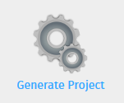

Make sure all subclass and module checkboxes are ticked and hit “Generate!”

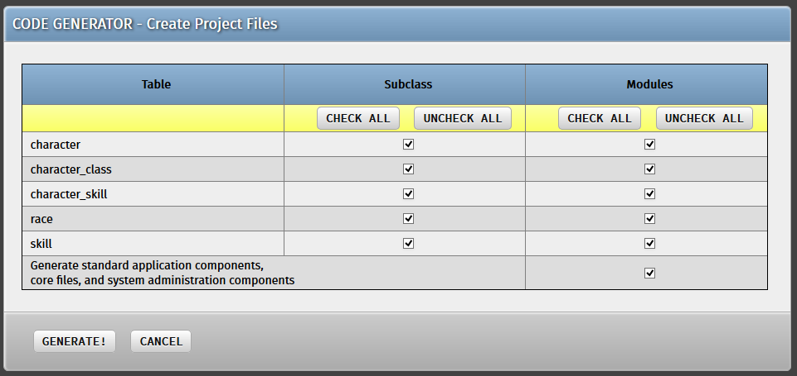

Wait a few seconds and voila – our project’s first prototype is ready!

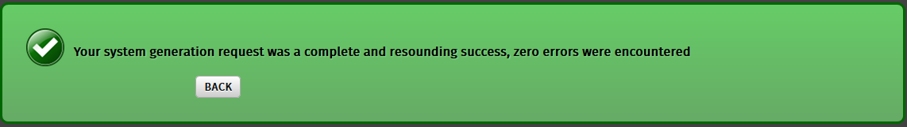

**THE FIRST PROTOTYPE IN ACTION**

With the project files generated, it’s now time to see how our work has developed so far. Navigate to the /cobalt folder inside your web root and look for your generated project inside /Generator/Projects

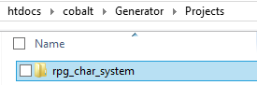

***Note:*** *The generated project’s directory name would be the name of the Base Directory we specified earlier during the project creation process.*

Copy this entire folder into your web root and access it via <http://localhost/rpg_char_system>

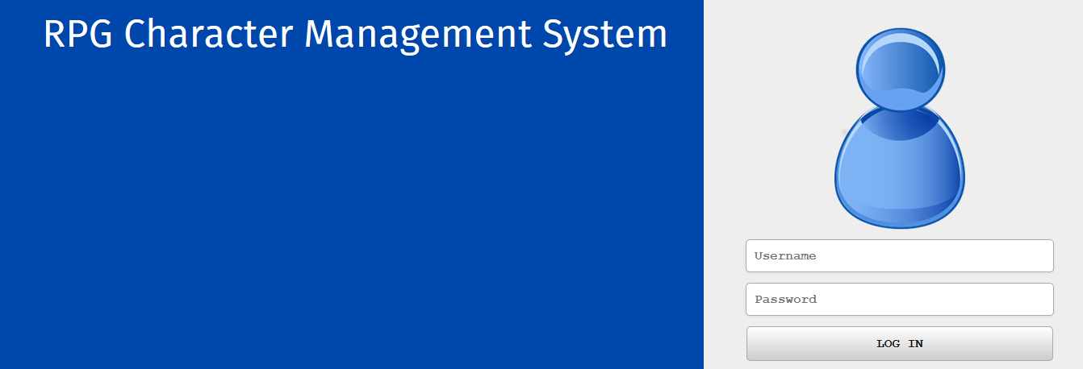

Before we can log in, we need to add a few more tables into our database which have been generated for us by Cobalt. Navigate to your new project’s folder in the web root and import the file **new_system.sql** into our char_rpg_db database through PhpMyAdmin.

Afterwards, log in using the following credentials:

* *Username:* root
* *Password:* password

If you are greeted by your project’s Control Center, then you have successfully managed to create the first prototype of your Cobalt-generated project!

